import pandas as pd  
import numpy as np  
import matplotlib.pyplot as plt  
  
from statsmodels.tsa.arima.model import ARIMA  
import warnings  
warnings.filterwarnings("ignore")  
import seaborn as sns  
import plotly.express as px  
  
from sklearn.model_selection import train_test_split  
from sklearn.ensemble import RandomForestRegressor  
from sklearn.metrics import mean_squared_error  
  
from sklearn.preprocessing import LabelEncoder, StandardScaler

df = pd.read_csv("/content/drive/MyDrive/DataSphere - Case Data - Network 18 (Updated).csv")

data = df.sample(frac=0.2)

# Assuming 'df' is your DataFrame  
  
  
data = df.sample(frac=0.05)  
# Specify the file path where you want to save the Excel file  
excel_file_path = "sample_data.xlsx"  
  
# Save the sampled data to an Excel file  
data.to_excel(excel_file_path, index=False)  
  
print(f"Excel file saved successfully at '{excel_file_path}'")

Excel file saved successfully at 'sample_data.xlsx'

data.isnull().sum()

Unnamed: 0 0  
Dimension.MONTH_AND_YEAR 0  
Dimension.REGION_NAME 0  
Dimension.COUNTRY_NAME 3479  
Column.TOTAL_CODE_SERVED_COUNT 0  
Column.TOTAL_INVENTORY_LEVEL_UNFILLED_IMPRESSIONS 0  
Column.TOTAL_LINE_ITEM_LEVEL_IMPRESSIONS 0  
Column.TOTAL_LINE_ITEM_LEVEL_CLICKS 0  
Column.TOTAL_LINE_ITEM_LEVEL_CPM_AND_CPC_REVENUE 0  
Column.TOTAL_LINE_ITEM_LEVEL_WITHOUT_CPD_AVERAGE_ECPM 0  
Column.TOTAL_LINE_ITEM_LEVEL_CTR 0  
Column.DROPOFF_RATE 0  
ad_size 0  
ad_type 0  
video_sub_class 1368038  
website 0  
major_sites 0  
sections 0  
home_ros 0  
device 0  
app_subclass 1288878  
ad_positions 0  
languages 0  
dtype: int64

mode_region = data['Dimension.REGION_NAME'].mode()[0]  
data['Dimension.REGION_NAME'].fillna(mode_region, inplace=True)

# Replace "your_data.csv" with the path to your dataset  
  
# Convert 'Dimension.MONTH_AND_YEAR' to datetime format  
data['Dimension.MONTH_AND_YEAR'] = pd.to_datetime(data['Dimension.MONTH_AND_YEAR'])  
  
# Group by 'Dimension.MONTH_AND_YEAR' and sum the impressions  
monthly_impressions = data.groupby('Dimension.MONTH_AND_YEAR')['Column.TOTAL_LINE_ITEM_LEVEL_IMPRESSIONS'].sum()  
  
# Fit ARIMA model  
model = ARIMA(monthly_impressions, order=(1,1,1))  
model_fit = model.fit()  
  
# Forecast next three months  
forecast = model_fit.forecast(steps=3)  
  
# Plot historical data and forecast  
plt.figure(figsize=(10, 6))  
plt.plot(monthly_impressions.index, monthly_impressions, label='Historical Data')  
plt.plot(pd.date_range(start=monthly_impressions.index[-1], periods=4, freq='M', tz='UTC')[1:], forecast, label='Forecast', linestyle='--', color='red')  
plt.title('Total Ad Impressions Forecast for the Next Three Months')  
plt.xlabel('Date')  
plt.ylabel('Total Ad Impressions')  
plt.legend()  
plt.grid(True)  
plt.show()

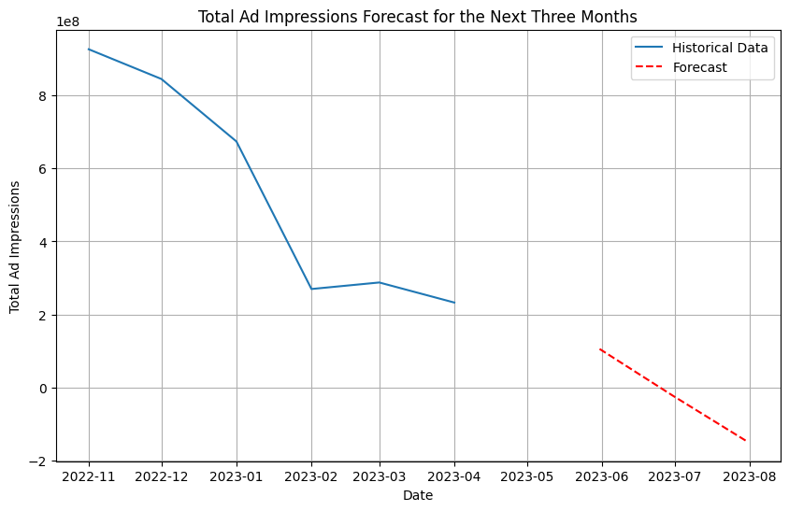

from statsmodels.tsa.arima.model import ARIMA  
  
  
  
# Convert 'Dimension.MONTH_AND_YEAR' to datetime format  
data['Dimension.MONTH_AND_YEAR'] = pd.to_datetime(data['Dimension.MONTH_AND_YEAR'])  
  
# Group by 'Dimension.MONTH_AND_YEAR' and sum the impressions  
monthly_impressions = data.groupby('Dimension.MONTH_AND_YEAR')['Column.TOTAL_LINE_ITEM_LEVEL_IMPRESSIONS'].sum()  
  
# Fit ARIMA model  
model = ARIMA(monthly_impressions, order=(1,1,1))  
model_fit = model.fit()  
  
# Forecast next three months  
forecast = model_fit.forecast(steps=3)  
  
# Extend the index to include future months  
extended_index = pd.date_range(start=monthly_impressions.index[0], periods=len(monthly_impressions)+3, freq='M')  
  
# Create a series with historical and forecasted values  
extended_impressions = monthly_impressions.append(pd.Series(forecast, index=extended_index[-3:]))

# Plot historical data and forecast  
plt.figure(figsize=(10, 6))  
plt.plot(extended_impressions.index, extended_impressions, label='Historical Data and Forecast', linestyle='-')  
plt.title('Total Ad Impressions Forecast for the Next Three Months')  
plt.xlabel('Date')  
plt.ylabel('Total Ad Impressions')  
plt.legend()  
plt.grid(True)  
plt.show()

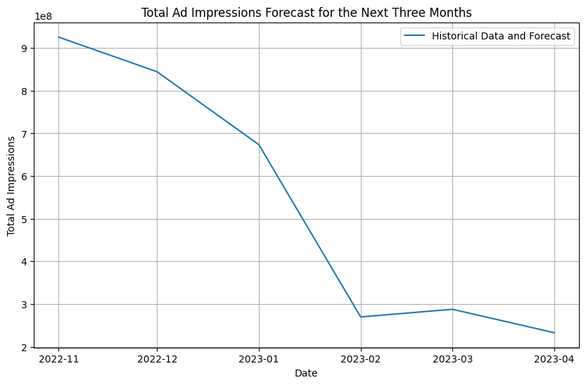

from statsmodels.tsa.arima.model import ARIMA  
  
  
  
# Convert 'Dimension.MONTH_AND_YEAR' to datetime format  
data['Dimension.MONTH_AND_YEAR'] = pd.to_datetime(data['Dimension.MONTH_AND_YEAR'])  
  
# Group by 'Dimension.MONTH_AND_YEAR' and sum the impressions  
monthly_impressions = data.groupby('Dimension.MONTH_AND_YEAR')['Column.TOTAL_LINE_ITEM_LEVEL_IMPRESSIONS'].sum()  
  
# Fit ARIMA model  
model = ARIMA(monthly_impressions, order=(1,1,1))  
model_fit = model.fit()

# Forecast next three months  
forecast = model_fit.forecast(steps=3)  
  
# Extend the index to include future months  
extended_index = pd.date_range(start=monthly_impressions.index[0], periods=len(monthly_impressions)+3, freq='M')  
  
# Create a series with historical and forecasted values  
extended_impressions = monthly_impressions.append(pd.Series(forecast, index=extended_index[-3:]))  
  
# Plot historical data and forecast  
plt.figure(figsize=(10, 6))  
plt.plot(extended_impressions.index[:-3], extended_impressions[:-3], label='Historical Data', linestyle='-', color='blue')  
plt.plot(extended_impressions.index[-3:], extended_impressions[-3:], label='Forecast', linestyle='--', color='red')  
plt.title('Total Ad Impressions Forecast for the Next Three Months')  
plt.xlabel('Date')  
plt.ylabel('Total Ad Impressions')  
plt.legend()  
plt.grid(True)  
plt.show()

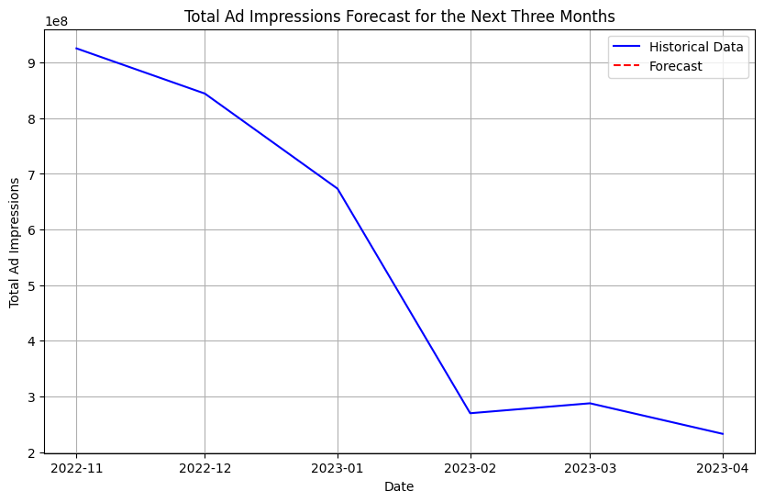

language_impressions = data.groupby('languages')['Column.TOTAL_LINE_ITEM_LEVEL_IMPRESSIONS'].sum()  
  
# Sort languages by impressions in descending order  
language_impressions_sorted = language_impressions.sort_values(ascending=False)  
  
# Create a color sequence using Plotly's default color scale  
color_sequence = px.colors.qualitative.Plotly  
  
# Create a Plotly bar chart with different colors for each bar  
fig = px.bar(x=language_impressions_sorted.index, y=language_impressions_sorted.values,  
 labels={'x': 'Language', 'y': 'Ad Impressions'},  
 title='Language-wise Ad Impressions (Descending Order)',  
 color_discrete_sequence=color_sequence,  
 template='plotly_white')  
  
# Rotate x-axis labels for better readability  
fig.update_layout(xaxis_tickangle=-45)  
  
# Show the plot  
fig.show()

# Group by language and sum the impressions  
language_impressions = data.groupby('languages')['Column.TOTAL_LINE_ITEM_LEVEL_IMPRESSIONS'].sum()  
  
# Sort languages by impressions in descending order and select top 5 languages  
top_5_languages = language_impressions.sort_values(ascending=False).head(5)  
  
# Define a function to forecast ad impressions for a given language using ARIMA  
def forecast_language(language):  
 # Filter data for the specified language  
 language_data = data[data['languages'] == language]  
  
 # Convert 'Dimension.MONTH_AND_YEAR' to datetime format  
 language_data['Dimension.MONTH_AND_YEAR'] = pd.to_datetime(language_data['Dimension.MONTH_AND_YEAR'])  
  
 # Group by month and sum the impressions  
 monthly_impressions = language_data.groupby('Dimension.MONTH_AND_YEAR')['Column.TOTAL_LINE_ITEM_LEVEL_IMPRESSIONS'].sum()  
  
 # Fit ARIMA model  
 model = ARIMA(monthly_impressions, order=(1, 1, 1))  
 model_fit = model.fit()  
  
 # Forecast next three months  
 forecast = model_fit.forecast(steps=3)

return forecast  
  
# Forecast ad impressions for each of the top 5 languages  
forecast_data = pd.DataFrame(columns=['Language', 'Month', 'Forecast'])  
  
for language in top_5_languages.index:  
 forecast = forecast_language(language)  
 forecast_data = forecast_data.append(pd.DataFrame({'Language': [language]*3,  
 'Month': pd.date_range(start=monthly_impressions.index[-1], periods=3, freq='M'),  
 'Forecast': forecast}), ignore_index=True)  
  
# Plot the forecasted ad impressions for the top 5 languages  
plt.figure(figsize=(10, 6))  
sns.lineplot(data=forecast_data, x='Month', y='Forecast', hue='Language', marker='o')  
plt.title('Forecasted Ad Impressions for Top 5 Languages')  
plt.xlabel('Month')  
plt.ylabel('Ad Impressions')  
plt.xticks(rotation=45)  
plt.grid(True)  
plt.legend(title='Language')  
plt.show()

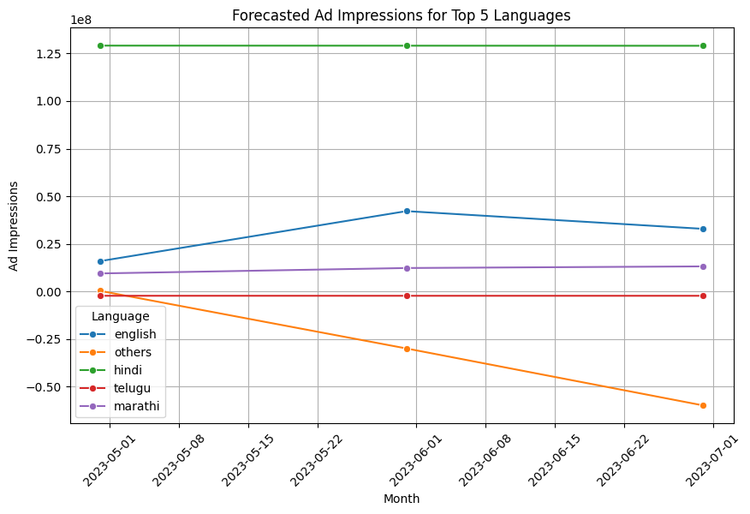

# Assuming 'data' is your DataFrame with region-wise impressions  
  
# Filter for top 10 regions by ad impressions  
top_10_regions = data.groupby('Dimension.REGION_NAME')['Column.TOTAL_LINE_ITEM_LEVEL_IMPRESSIONS'].sum().nlargest(10)  
  
# Plot the bar graph  
plt.figure(figsize=(10, 6))  
sns.barplot(x=top_10_regions.values, y=top_10_regions.index, palette='viridis')  
plt.title('Top 10 Regions by Ad Impressions')  
plt.xlabel('Ad Impressions')  
plt.ylabel('Region')  
plt.grid(True, axis='x')  
plt.show()

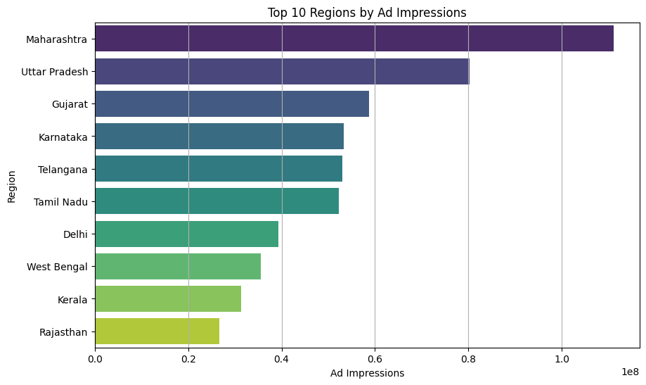

# Group by region and sum the ad impressions for each region  
region_impressions = data.groupby('Dimension.REGION_NAME')['Column.TOTAL_LINE_ITEM_LEVEL_IMPRESSIONS'].sum()  
  
# Select the top 5 regions with the highest ad impressions  
top_5_regions = region_impressions.nlargest(5)  
  
# Initialize a dictionary to store forecasts for each region  
region_forecasts = {}  
  
# Iterate over the top 5 regions and apply ARIMA model to forecast ad impressions  
for region in top_5_regions.index:  
 # Filter data for the current region  
 region_data = data[data['Dimension.REGION_NAME'] == region]  
  
 # Group by month and sum ad impressions  
 monthly_impressions = region_data.groupby('Dimension.MONTH_AND_YEAR')['Column.TOTAL_LINE_ITEM_LEVEL_IMPRESSIONS'].sum()  
  
 # Define and fit the ARIMA model  
 model = ARIMA(monthly_impressions, order=(5, 1, 0)) # Example order, you can adjust it  
 model_fit = model.fit()  
  
 # Forecast ad impressions for the next 12 months  
 forecast = model_fit.forecast(steps=12)  
  
 # Store the forecast for the current region  
 region_forecasts[region] = forecast  
  
# Plot the forecasted ad impressions for each region  
plt.figure(figsize=(12, 8))  
for region, forecast in region_forecasts.items():  
 plt.plot(forecast.index, forecast.values, label=region)  
  
plt.title('Forecasted Ad Impressions for Top 5 Regions')  
plt.xlabel('Month')  
plt.ylabel('Ad Impressions')  
plt.legend()  
plt.grid(True)  
plt.show()

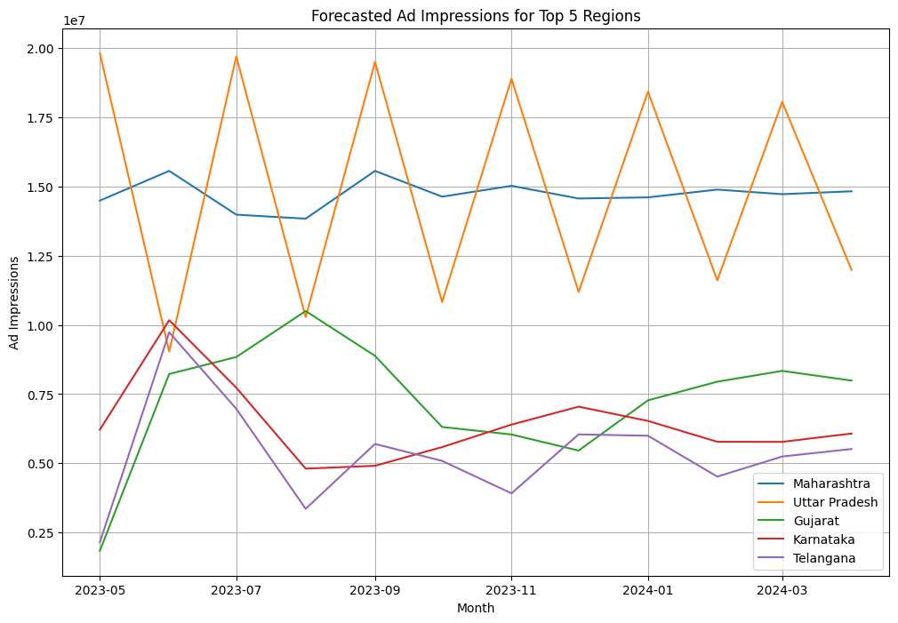

# Filter out rows with missing values in ad_size and ad_type columns  
data = data.dropna(subset=['ad_size', 'ad_type'])  
  
# Group the data by ad_size and ad_type and sum the impressions  
impressions_by_ad = data.groupby(['ad_size', 'ad_type'])['Column.TOTAL_LINE_ITEM_LEVEL_IMPRESSIONS'].sum().reset_index()  
  
# Plot the data using seaborn  
plt.figure(figsize=(12, 8))  
sns.barplot(x='ad_size', y='Column.TOTAL_LINE_ITEM_LEVEL_IMPRESSIONS', hue='ad_type', data=impressions_by_ad)  
plt.title('Impressions by Ad Size and Ad Type')  
plt.xlabel('Ad Size')  
plt.ylabel('Total Impressions')  
plt.xticks(rotation=45)  
plt.tight_layout()  
plt.show()

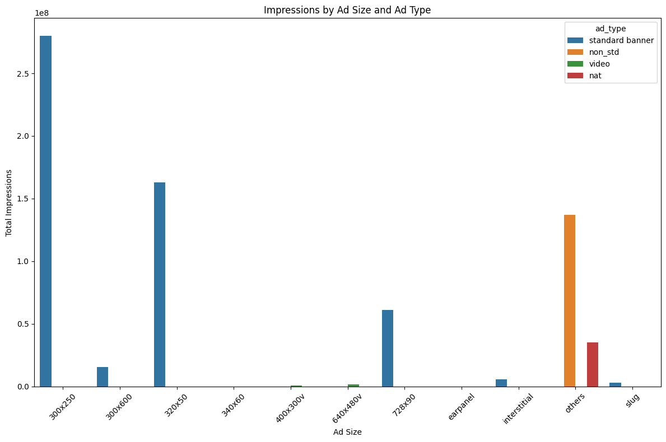

# Create a dataframe for visualization  
impression_barplot = impression_lineplot.groupby('Ad Size')['Predicted Impressions'].mean().reset_index()  
  
# Set up the plot  
fig, ax1 = plt.subplots(figsize=(12, 6))  
  
# Plot bar graph for average predicted impressions by ad size  
sns.barplot(x='Ad Size', y='Predicted Impressions', data=impression_barplot, ax=ax1, color='skyblue')  
ax1.set_ylabel('Predicted Impressions (Average)')  
  
# Set up the second y-axis for line plot  
ax2 = ax1.twinx()  
  
# Plot line graph for predicted impressions by ad type  
for ad_type in ad_types:  
 ad_type_data = impression_lineplot[impression_lineplot['Ad Type'] == ad_type]  
 ax2.plot(ad_type_data['Ad Size'], ad_type_data['Predicted Impressions'], label=ad_type)  
  
# Add labels and legend  
ax2.set_ylabel('Predicted Impressions')  
ax2.legend(title='Ad Type', loc='upper right')  
  
# Show plot  
plt.title('Predicted Impressions by Ad Size and Ad Type')  
plt.xlabel('Ad Size')  
  
plt.show()

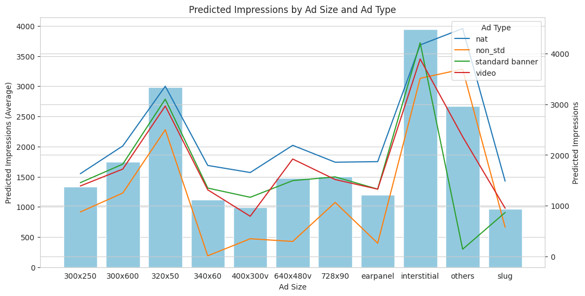

# Extract relevant columns  
df = data[['ad_type', 'ad_size', 'Column.TOTAL_LINE_ITEM_LEVEL_IMPRESSIONS']]  
  
# Encode categorical variables  
df['ad_type'] = pd.Categorical(df['ad_type']).codes  
df['ad_size'] = pd.Categorical(df['ad_size']).codes  
  
# Calculate correlation coefficients  
correlation_matrix = df.corr()  
  
# Create heatmap  
plt.figure(figsize=(10, 8))  
sns.heatmap(correlation_matrix, annot=True, cmap='coolwarm', fmt=".2f", linewidths=0.5)  
plt.title('Correlation Heatmap of Ad Type, Size, and Impressions')  
plt.show()  
sns.pairplot(df)  
plt.show()

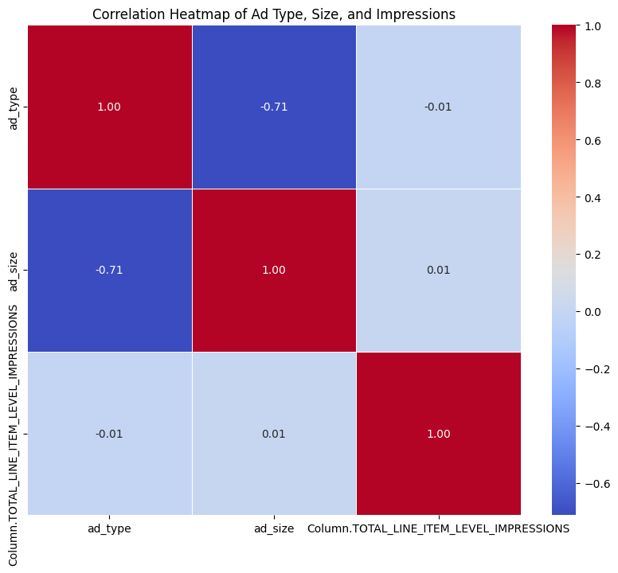

# Extract relevant columns  
df = data[['ad_type', 'ad_size', 'Column.TOTAL_LINE_ITEM_LEVEL_IMPRESSIONS']]  
  
# Encode categorical variables  
df['ad_type'] = pd.Categorical(df['ad_type']).codes  
df['ad_size'] = pd.Categorical(df['ad_size']).codes  
  
# Calculate correlation coefficients  
correlation_matrix = df.corr()  
correlation_matrix

{"summary":"{\n \"name\": \"correlation_matrix\",\n \"rows\": 3,\n \"fields\": [\n {\n \"column\": \"ad_type\",\n \"properties\":